**Introduction**

Bright Ideas Consulting, a consulting firm, relies on Zoho Books to track their billable hours, expenses, and client invoices. The software helps them accurately calculate project costs, monitor profitability, and generate reports for better financial management.

Bright Ideas Consulting is a Private Limited company also registered under GST in Tamil Nadu. Bright Ideas Consulting offers various expert consulting services in India and outside India.

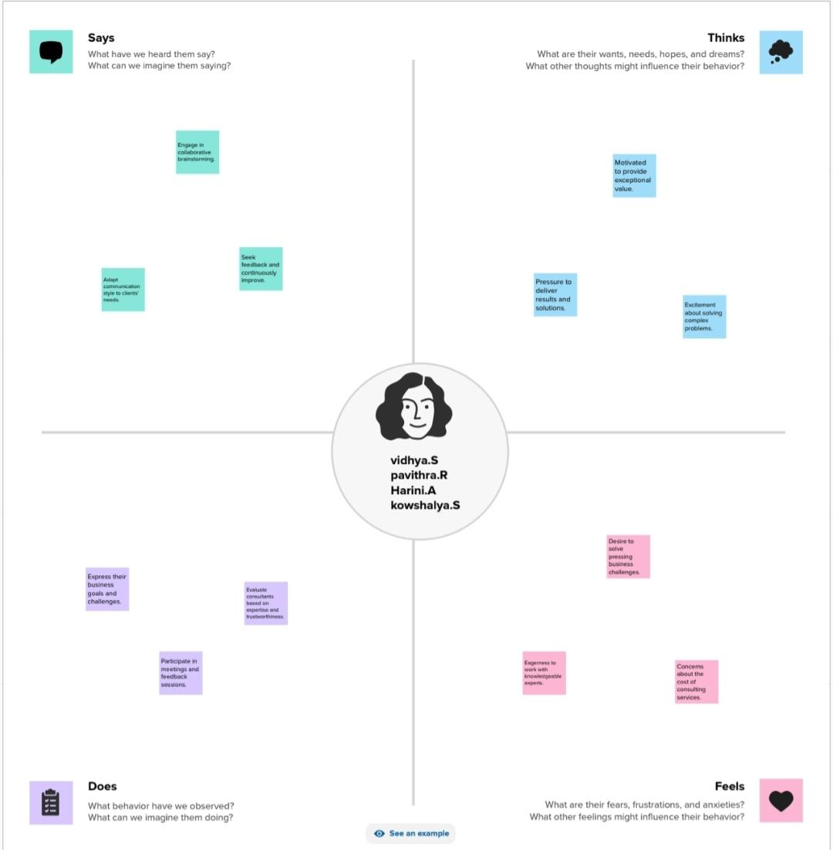**Empathy map**

**Brainstorming and prioritization**

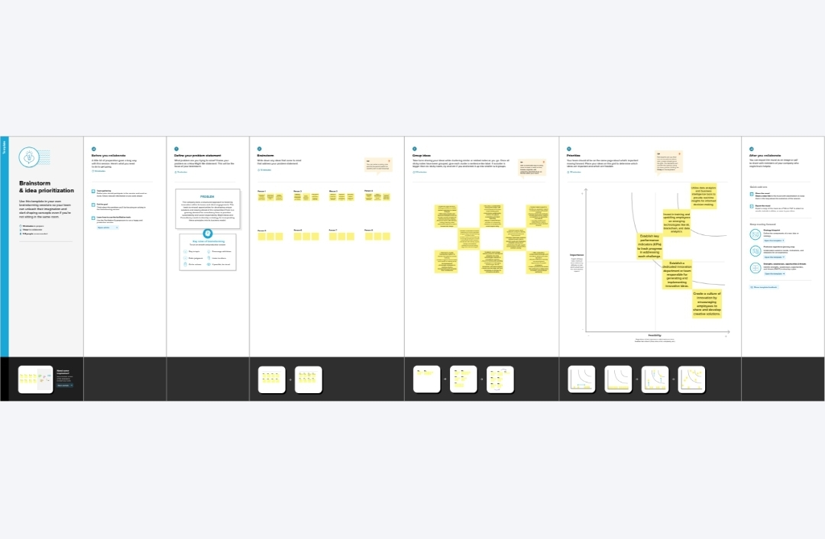

**Result**

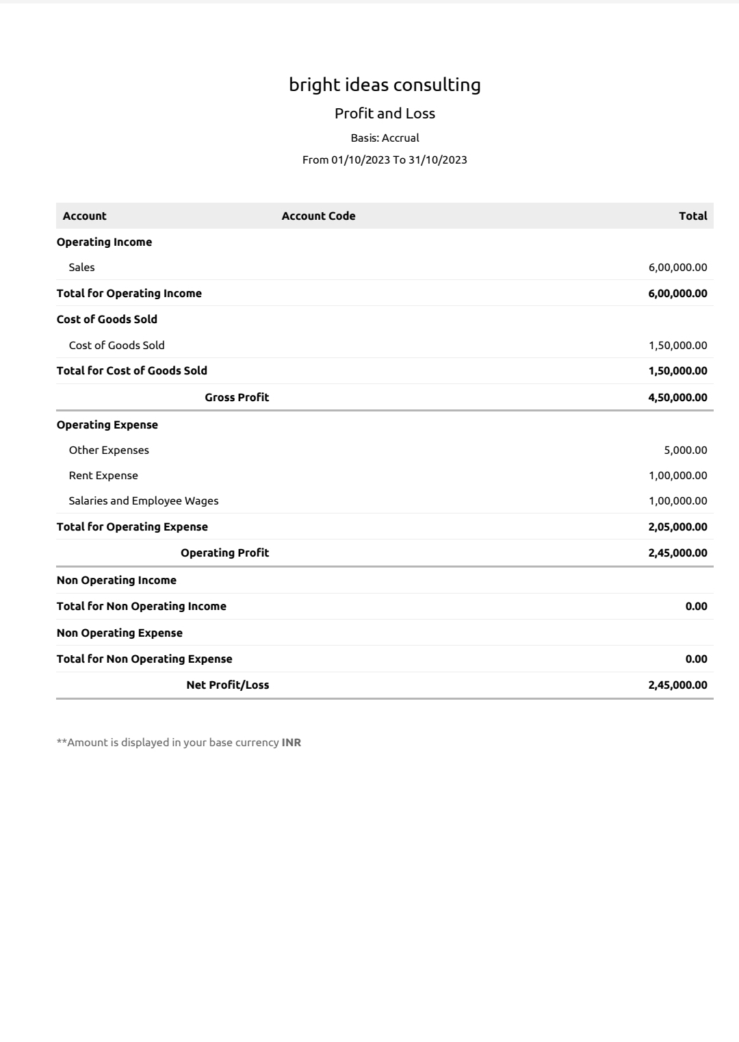**profit and loss:**

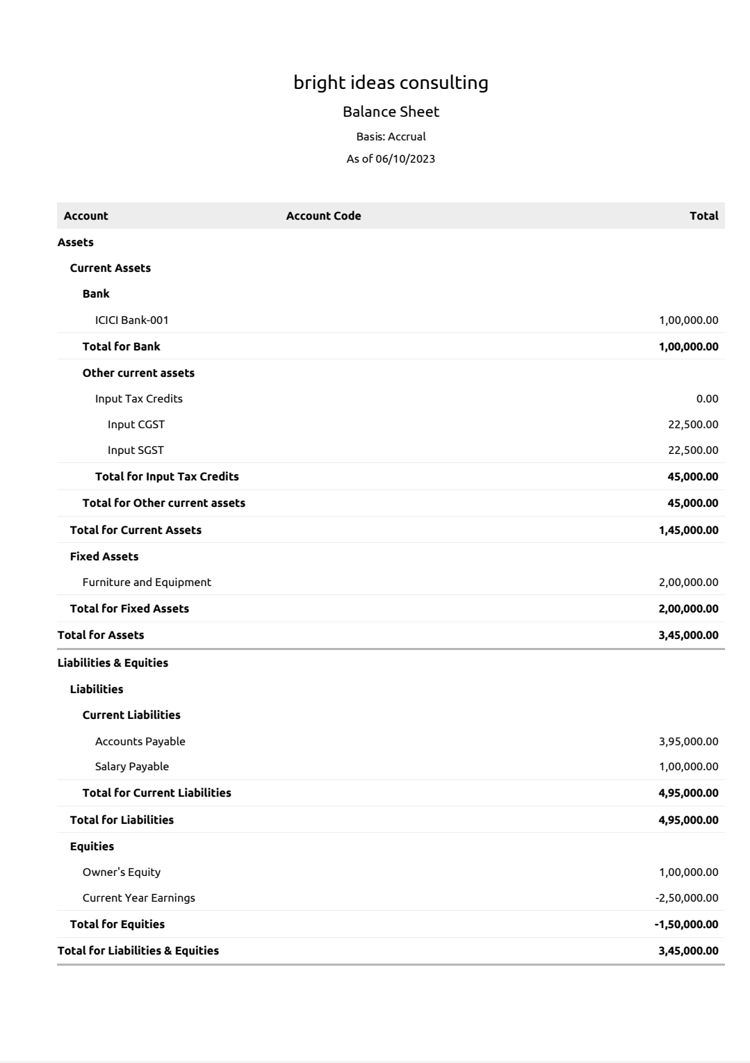

**Balance sheet:**

**Advantages :**

* **Expertise: Consulting services can provide you with access to accounting and financial experts who can help you set up and use Zoho Books effectively. They can offer guidance on best practices and tailor the software to your specific needs.**
* **Time-saving: Consultants can help streamline your financial processes, saving you time and effort. This allows you to focus on other aspects of your business while ensuring your accounting is accurate and up-to-data**

**Disadvantages :**

* **Limited Features: While Zoho Books offers many essential accounting features, it may lack some advanced features that larger businesses or industries with specific needs require.**
* **Learning Curve: While the software is user-friendly, there can still be a learning curve for users who are new to accounting software or financial management.**

**Conclusion :**

**Bright Ideas Consulting could benefit significantly from using Zoho Books as its accounting and financial management software. Zoho Books offers a user-friendly interface, affordable pricing, and a range of features that can streamline financial processes, saving time and reducing the risk of errors. The cloud-based nature of the software provides flexibility and accessibility, which is especially valuable in today’s remote work environment.**